SMART GLOVE FOR SIGN LANGUAGE CONVERTION
SUBMITTED BY
BASIL REJI
ANJALI RATHESH
IN PARTIAL FULFILLMENT OF REQUIREMENT FOR THE AWARD OF
DEGREE OF
BACHELOR OF TECHNOLOGY
IN
ELECTRICAL AND ELECTRONICS ENGINEERING
DIVISION OF ELECTRICAL ENGINEERING


SCHOOL OF ENGINEERING
COCHIN UNIVERSITY OF SCIENCE AND TECHNOLOGY
COCHIN-682022

ABSTRACT

This report is on the implementation of “SMART GLOVE FOR SIGN LANGUAGE CONVERSION”. Roughly 27.8% of the total population of India can’t either hear or speak. Sign language is a non-verbal form of communication method which is found among all deaf and dumb communities. Normal people do not learn sign language, it causes barriers in communication between deaf and dumb people. Hence to break this barrier we design a system which converts hand gestures into auditory speech as well as text. The system is being proposed with use of flex sensors and android technology. There are 2 modules, first is a glove with flex sensors and Atmel ATMEGA328 PU microcontroller and second is an android app with Google speech API.

INTRODUCTION

About eighteen million people in the planet are dumb or deaf. The communication between a dumb and hearing person becomes difficult because sign languages are unknown to normal people. Also, even the communication among deaf people are a bit hard due the disparities of sign languages from nation to nation. This creates an extremely little house for them, with communication being an associate degree for elementary aspect of human life. The languages haven't got a typical origin and hence are hard to interpret. A dumb communication interpreter is also a tool that interprets the hand gestures to sensible speech.
The primary aim of this paper is to introduce an issue that will efficiently translate hand gestures into its equivalent textual and voice representation. The interpreter makes use of a glove totally based on the technique comprising of flex sensors. For each hand gesture created by the right hand, 5 sets of voltage combinations are formed by the sensors for further processing in the microcontroller. Then the controller matches the gesture with pre-stored inputs. The output is brought with the help of an android smartphone using an android app.
SIGN LANGUAGE

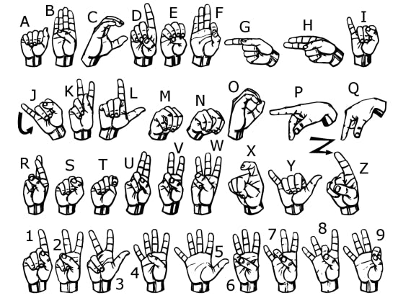
TRACK AND SCOPE

The Smart Glove for Sign Language Conversion is a project related to the medical field. It improves the scope of communication to a greater extend and hence improves the opportunity of the people with hearing and speaking disabilities. The people with such disabilities will be able to communicate very easily through this smart glove. We have taken up this project to check the feasibility and to make it in the cheapest possible way so that it is accessible to all.
Even though this is an existing idea, it has not been into the access of many. But we have successfully implemented the project in the best possible way and can be used very easily by any users. By increasing the scope of this project further into a larger scale of production, the study and job opportunities of a greater section of our society will increase to a large extend. They will be able to express their ideas with the normal people in easy way and our world will have a brighter future.

PROBLEM STATEMENT AND OPTIMIZED
SOLUTION

The Smart Glove for hand gesture recognition is designed primarily to detect the hand gestures and produce both audio and text message of the recognized gesture’s meaning. This is designed mainly to assist deaf, dumb and partially paralyzed people. Such people can only communicate using sign language. And since sign language is not much familiar to common people and they vary from nation to nation, this device helps common men understand these complex symbols.

BLOCK DIAGRAM
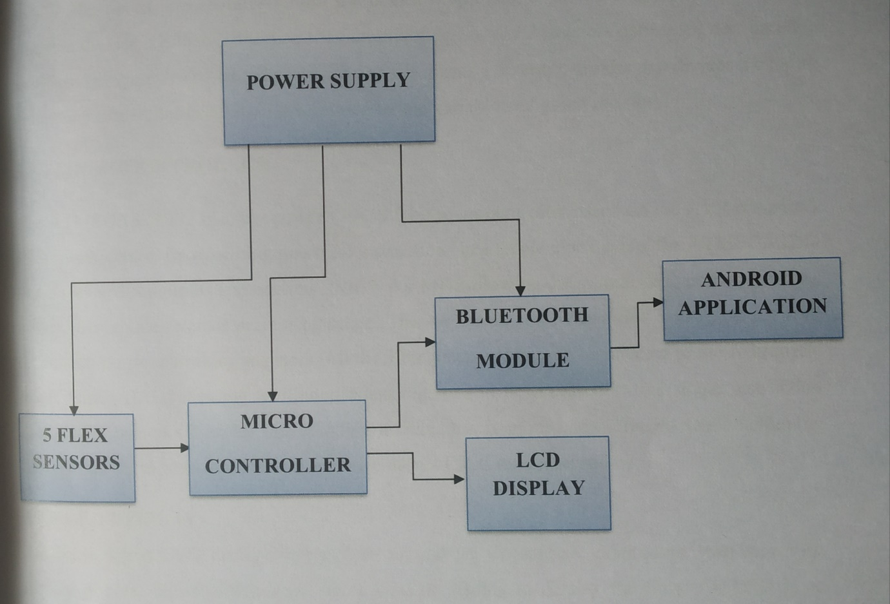

BLOCK DIAGRAM DESCRIPTION

1)POWER SUPPLY
The power supply is designed to convert high DC voltage to low DC voltage for the electronic devices used in the circuit. The main power source of the circuit is 12V battery. But the most of the devices used in the circuit work on 5V DC supply. So we use 7805 Voltage regulator to covert 12V DC supply to 5V DC supply which in turn powers the Flex sensors and Microcontroller. The Bluetooth module and LCD Display are powered by microcontroller
2)FLEX SENSORS
Flex sensors are resistive carbon parts. When bent, the device develops a resistance output correlative to the bend radius. The variation in resistance is just about 10kΩ to 30kΩ. A global organization flexed device has 10kΩ resistance and once bent the resistance will increase to 30kΩ at 90o. The device incorporates within the device employing a potential divider network. The potential divider is employed to line the output voltage across 2 resistors connected non-parallel as shown in Figure 2. The electrical device and flex forms a potential divider that divides the input voltage by a quantitative relation determined by the variable and glued resistors.
3) MICROCONTROLLER
The ATMEGA328-PU is a low power CMOS 8 bit microcontroller based on the AVR enhanced RISC architecture. By executing powerful instructions in a single clock cycle, the ATMEGA328-PU achieves throughputs approaching 1MIPS per MHz allowing the system designed to optimize power consumption versus processing speed. The AVR core combines a rich instruction set with 32 general purpose working registers. All the 32 registers are directly connected to the Arithmetic Logic Unit (ALU), allowing two independent registers to be accessed in one single instruction executed in one clock cycle. The resulting architecture is more code efficient while achieving throughputs up to ten times faster than conventional CISC microcontrollers.
4) LCD.DISPLAY
We come across LCD displays everywhere around us. Computers, calculators, television sets, mobile phones, digital watches use some kind of display to display the time. An LCD is an electronic display module which uses liquid crystal to produce a visible image. The 16×2 LCD display is a very basic module commonly used in DIYs and circuits. The 16×2 translates a display 16 characters per line in 2 such lines. In this LCD each character is displayed in a 5×7-pixel matrix.
5) BLUETOOTH MODULE
It is used for many applications like wireless headset, game controllers, wireless mouse, wireless keyboard and many more consumer applications. It has range up to <100m which depends upon transmitter and receiver, atmosphere, geographic & urban conditions. HC-05 is a Bluetooth module which is designed for wireless communication. This module can be used in a master or slave configuration. HC-05 is a Bluetooth module which is designed for wireless communication. This module can be used in a master or slave configuration.
6) ANDROID APPLICATION
In this project we are using an Android application for text to speech conversion. The microcontroller interprets the hand gesture and generate respective messages. These messages are send to the Android app through Bluetooth. The app converts these text messages to the respective audio messages which are transmitted by the phone’s speakers

COMPONENT SPECIFICATION
1) ATMEGA 328PU
This microcontroller is considered as the heart of the project. ATmega328 is an 8-bit and 28 Pins AVR Microcontroller, manufactured by Microchip, follows RISC Architecture and has a flash type program memory of 32KB.It has an EEPROM memory of 1KB and its SRAM memory is of 2KB,8 Pin for ADC operations, which all combines to form Port A ( PA0 – PA7). It also has 3 built in Timers, two of them are 8 Bit timers while the third one is 16-Bit Timer. It operation ranging from 3.3V to 5.5V but normally we use 5V as a standard.
We use Arduino nano which is a development board which uses ATMEGA 328PU as the microcontroller. The Arduino Nano is programmed using the Arduino Software (IDE), our Integrated Development Environment common to all Arduino boards and running both online and offline
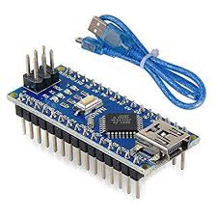
2) FLEX SENSORS
FLEX SENSOR is basically a VARIABLE RESISTOR whose terminal resistance increases when the sensor is bent. So this sensor resistance increases depends on surface linearity. So it is usually used to sense the changes in linearity. Flex sensors are usually available in two sizes. One is 2.2 inch and another is 4.5 inch. Although the sizes are different the basic function remains the same. They are also divided based on resistance. There are LOW resistance, MEDIUM resistance and HIGH resistance types. Choose the appropriate type depending on requirement. FLEX SENSOR terminal resistance changes when it is bent.
2.1) Pin description
PIN NUMBER | DESCRIPTION
P1 | Usually connected to positive of power source
P2 | Usually connected to ground
2.2) Features and Specifications

- Operating voltage of FLEX SENSOR: 0-5V
- Can operate on LOW voltages
- Power rating : 0.5Watt (continuous), 1 Watt (peak)
- Life: 1 million
- Operating temperature: -45ºC to +80ºC
- Flat Resistance: 25K Ω
- Resistance Tolerance: ±30%
- Bend Resistance Range: 45K to 125K Ohms(depending on bend)

2.3) WORKING

As shown above figure, when the surface of flex sensor is completely linear it will be having its nominal resistance. When it is bent 45º angle the flex sensor resistance increases to twice as before. And when the bent is 90º the resistance could go as high as four times the nominal resistance. So, the resistance across the terminals rises linearly with bent angle. So, in a sense the flex sensor converts flex angle to resistance parameter.

3) LCD DISPLAY
LCD modules are very commonly used in most embedded projects, the reason being its cheap price, availability and programmer friendly. Most of us would have come across these displays in our day to day life, either at PCO’s or calculators.16×2 LCD is named so because; it has 16 Columns and 2 Rows. There are a lot of combinations available like, 8×1, 8×2, 10×2, 16×1, etc. but the most used one is the 16×2 LCD.
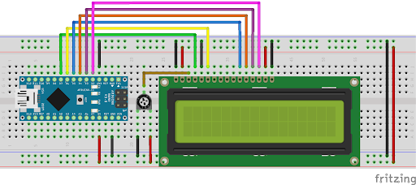
3.1) FEATURES

- Operating Voltage is 4.7V to 5.3V
- Current consumption is 1mA without backlight
- Alphanumeric LCD display module, meaning can display alphabets
and numbers
- Consists of two rows and each row can print 16 characters
- Each character is built by a 5×8 pixel box
- Can work on both 8-bit and 4-bit mode
- It can also display any custom generated characters
- Available in Green and Blue Backlight

4) BLUETOOTH MODULE HC-05
HC-05 module is an easy to use Bluetooth SPP (Serial Port Protocol) module, designed for transparent wireless serial connection setup. Serial port Bluetooth module is fully qualified Bluetooth V2.0+EDR (Enhanced Data Rate) 3Mbps Modulation with complete 2.4GHz radio transceiver and baseband. It uses CSR Blue core 04-External single chip Bluetooth system with CMOS technology and with AFH (Adaptive Frequency Hopping Feature). It has the footprint as small as 12.7mmx27mm. Hope it will simplify your overall design/development cycle.
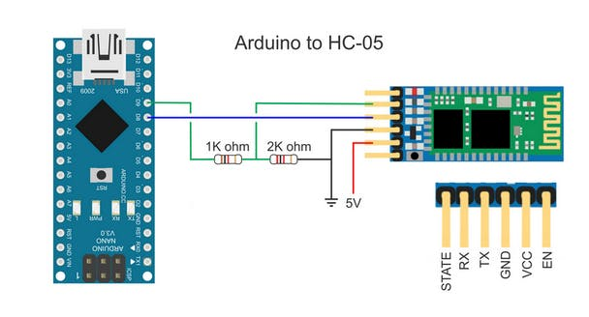

4.1) FEATURES

- Serial Bluetooth module for Arduino and other microcontrollers
- Operating Voltage: 4V to 6V (Typically +5V)
- Operating Current: 30Ma
- Range: <100m
- Works with Serial communication (USART) and TTL compatible
- Follows IEEE 802.15.1 standardized protocol
- Uses Frequency-Hopping Spread spectrum (FHSS)
- Can operate in Master, Slave or Master/Slave mode

5) 7805 VOLTAGE REGULATOR
Voltage sources in a circuit may have fluctuations resulting in not providing fixed voltage outputs. A voltage regulator IC maintains the output voltage at a constant value. 7805 IC, a member of 78xx series of fixed linear voltage regulators used to maintain such fluctuations, is a popular voltage regulator integrated circuit (IC).7805 IC provides +5 volts regulated power supply with provisions to add a heat sink.

6) ACCELEROMETER ADXL335

The ADXL335 is a small, thin, low power, complete 3-axis accelerometer with signal conditioned voltage outputs. Measures acceleration with a minimum full-scale range of ±3g.It can measure the static acceleration of gravity in tilt-sensing applications, as well as dynamic acceleration resulting from motion, shock, or vibration.
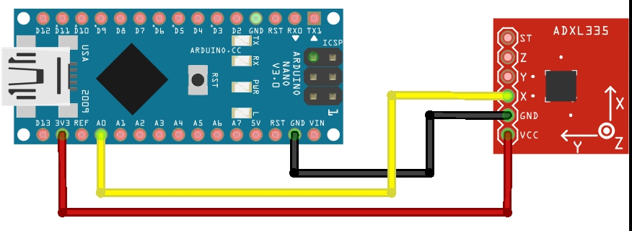

CIRCUIT DIAGRAM AND EXPLAINATION

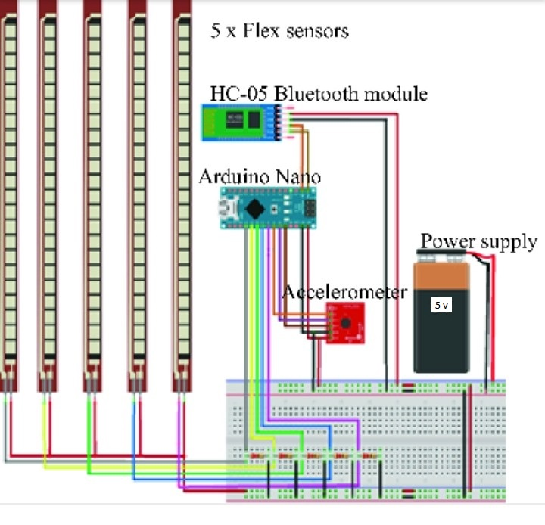

SOFTWARE SECTION

- ARDUINO IDE

The Arduino Integrated Development Environment (IDE) is a cross-platform application (for Windows, macOS, Linux) that is written in functions from C and C++. It is used to write and upload programs to Arduino compatible boards.
The source code for the IDE is released under the GNU General Public License, version 2. The Arduino IDE supports the languages C and C++ using special rules of code structuring. The Arduino IDE supplies a software library from the Wiring project, which provides many common input and output procedures. User-written code only requires two basic functions, for starting the sketch and the main program loop, that are compiled and linked with a program stub main ( ) into an executable cyclic executive program with the GNU toolchain, also included with the IDE distribution. The Arduino IDE employs the program avrdude to convert the executable code into a text file in hexadecimal encoding that is loaded into the Arduino board by a loader program in the board's firmware.
The Atmega328p microcontroller, like any other microcontroller, can be quite tasking to use for a beginner. They usually require a certain set of tools, including a programmer (hardware), and a development platform (e.g. Atmel Studio) for writing code. These development platforms, unlike the Arduino IDE usually require high knowledge of C or other programming languages, without the shortcuts and simplified functions which the Arduino provides. To remove this difficulty, the microcontroller is flashed with the Arduino bootloader, which makes it ready for programming using the simpler and easy to use Arduino IDE.
To program the microcontroller using the Arduino IDE, the microcontroller must be connected via some sort of hardware to the computer. This is usually done via two major ways:
1. Using a USB to Serial/TTL Adapter
2. Using an Arduino board
Each of these approaches provides the microcontroller with an interface that enables interaction between the computer and the microcontroller.

- PROTEUS

Proteus is software for microprocessor simulation, schematic capture, and printed circuit board (PCB) design. It is developed by Lab Centre Electronics. Proteus is considered as an important tool for computer aided design. It is a complete electronic design system which lets to simulate entire microprocessor design running actual processor machine code a real time. Proteus includes ISIS schematic capturing software, ProSpice (SPICE3FS) including auto placer and auto router and several virtual system modelling including 8051, 8052, PIC16F873 etc. It combines a super mixed mode circuit simulator based on industry standard SPICE3FS with animated components models and provides an architecture in which additional models can created by anyone including end user.
Consequently, the program allows professional engineers to run interactive simulations of real designs and reap the rewards of this approach to circuit simulation. Proteus features range of simulator models for popular microcontrollers and set of animated models for related peripheral devices such as LED, LCD display, keypads and RS232 terminals. The software also includes various templates such as text styles and graphic colures ability to export graphics (BMP, DXF, EPS, HGL and WMF)

- ANDROID APPLICATION

The app we used in this project is “ARDUINO BLUETOOTH TEXT TO SPEECH”. Arduino Bluetooth CH-05, CH-06 can communicate with the app by sending text. Arduino Bluetooth CH-05, CH-06 can communicate with the app by sending text (new line at the end of each transmission). It will convert the text received to speech.
Text to speech (TTS) makes an android device read the text and convert it to audio out via the speaker. Android TTS supports multiple languages. TTS is a simple but powerful feature. It can also be effectively used in mobile APPs dedicated to visually impaired people or in educational app for kids or can be used in pronunciation learning app, etc. These are some of the ways you can use TTS. Using Text to Speech enhances interaction between the user and the mobile application.

FLOWCHART

START

POWER ON

GLOVE OF SIGN LANGUAGE

NO
GLOVE CALIBERATED

YES
VALUES ARE CAPTURED BY THE ADC OF THE MICROCONTROLLER

DOES THE 5 DIGITAL VALUES MATCH THE GIVEN VALUES PROVIDED BY THE MICROCONTROLLER?

NO
NO OUTPUT DISPLAY ON LCD

YES

OUTPUT DISPLAYED ON LCD
WORKING

Disabled use these gloves to convert sign performed by them into speech. From the convenience of simple flex sensors, a user is able to interact with others in more comfortable and easier manner. This makes it possible for the user to not only interact with their community but with others also and they can also live normal life. The end product will have a cheap and simplistic design making it easy for users to interact with. The system is capable of recognizing signs more quickly. Furthermore, real time recognition ratio of nearly 99% can be easily achieved.
The averaging we do at each interval helps to account for any noise or glitches that the flex sensors are sometimes prone to. The accuracy of the glove is also somewhat limited by the size of the person’s hands. The accuracy of each flex sensor is limited beyond a certain point. Smaller hands will result in a larger degree of bend. As a result, the difference between slightly different signs with a lot of flex might be too small for users with small hands. The device uses a low voltage environment, and extremely low frequency communication. The sensors are well attached, and there are no sharp edges. As a result, we don’t see any large safety issues associated with the glove. Furthermore, since all communication is done via cables, our device does not interfere with other designs. The glove can be used by anyone who fits into it, they would only have to train on it and generate new datasets if they wish for a higher prediction accuracy than the standard or to incorporate new signs.
The message displayed on the “Arduino Bluetooth Text to Speech” app for the hand gesture of ‘Hello’ is shown in the image below.
LCD display is as shown
- Hello

- Thanks

CONCLUSION AND FUTURE SCOPE

Sign language is a method used for communication by disabled person. Here we are converting sign language into text and speech so that communication is not limited between them only, utilizing data gloves communication barrier between two different communities is eliminated. Using smart gloves disabled person can also grow in their carrier and makes nation grow as percentage of disabled person are millions in count. Making their future better and hence making nation better.
This report gives a brief about the project that is useful for speech or hear impaired patients. This work was able to meet our expectations quite well. This project was meant to be a finished device to check the feasibility of recognizing sign languages using sensor gloves. The completion of this project suggests that sensor gloves can be used for partial sign language recognition.

PROJECT LINK

https://drive.google.com/folderview?id=18C8A3AmBqj4Ma23p4CTiNWrQIXDuhjdH

